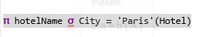

Extra Statement:

select hotelName
from Hotel
WHERE City = 'Paris'

